EQUIPMENT

SL  No. | TestingKitName | Brand/Origin | TestingKitPhoto
01 | Multi-Functional-  Primary Injection test set for Substation Testing and commissioning work | ModelNo.:CPC-100 OMICRON, Austria.  Specs:  Up to 800 A or 2000 V with up to 5 kVA over a  frequency range of 15 Hz - 400 Hz or 400 A DC  ➢ Excellent interference suppression facilitates  measurement of small signals  ➢ Easy to transport (just 29 kg) – ideal for on-site testing  ➢ Testing templates, automatically generated  testing procedures and test reports  ➢ Up to 2000 A or 12 kV/ 15kV through use of  current or voltage amplifiers | 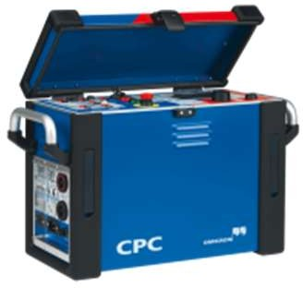
02 | 2000A Current Booster : Output current of the CPC100 gets increased to upto 2000 A | ModelNo.:CP-CB2 OMICRON, Austria | 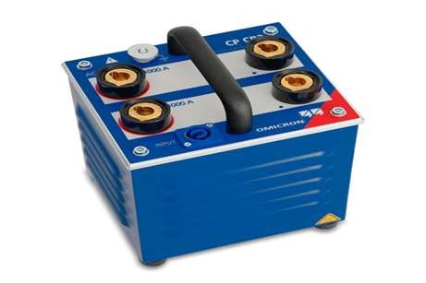
03 | The CP TD12 are accessories for CPC 100 for performing power/dissipation factor and capacitance measurements | 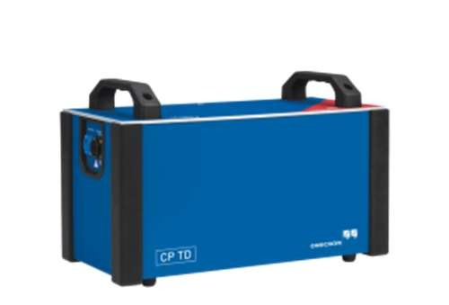  ModelNo.:CP-TD12 OMICRON, Austria
04 | Universal Protection Relay test set and commissioning tool | ModelNo.:CMC356 OMICRON, Austria | 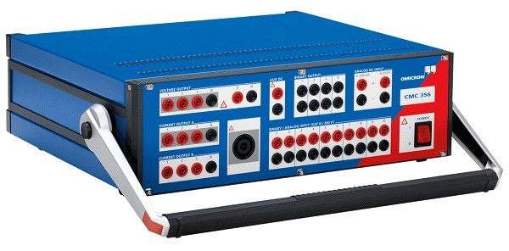
05 | Double Stage High Vacuum Transformer Oil Centrifuging Capacity:6000Litter/ Hour | Model No.: ZYD-150 Rexon Oil PurifierCo. Ltd., China | 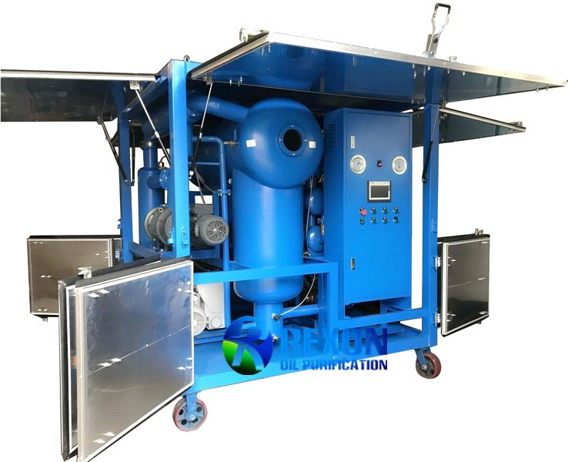
06 | DoubleStageVacuumPumpwith Booster Pump set  Capacity:70Litter/ Second | Model No.: RNVS-70 Rexon Oil PurifierCo. Ltd., China | 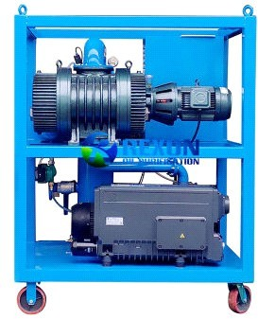
07 | Break Down Voltage(BDV)Test Kit (100 kV) | ModelNo.:IIJ-II-100  Rexon Oil PurifierCo. Ltd., China | 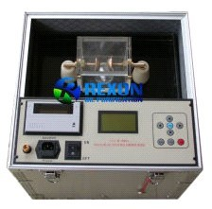

08 | Dew Point Meter(DM-70) and Moisture Test meter(MM-70) | Brand:VAISALA,Finland  Power supply: Rechargeable battery  Operating temperature: (+14 … +104 °F)  Operating humidity: 0 ... 100 % RH  Water Activity  Measurement range: 0 ... 1 𝑎𝑤  Temperature  Measurement range: (-40 ... +212 °F)  Typical accuracy (+20°C): (±0.36 °F) | 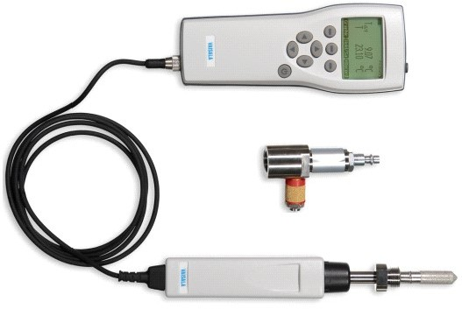
09 | Dry Air Generator (DAG) for Transformer Erection Works  Capacity : 120M³/Hour | Model No.:  DAG 120 Rexon Oil Purifier Co. Ltd., China | 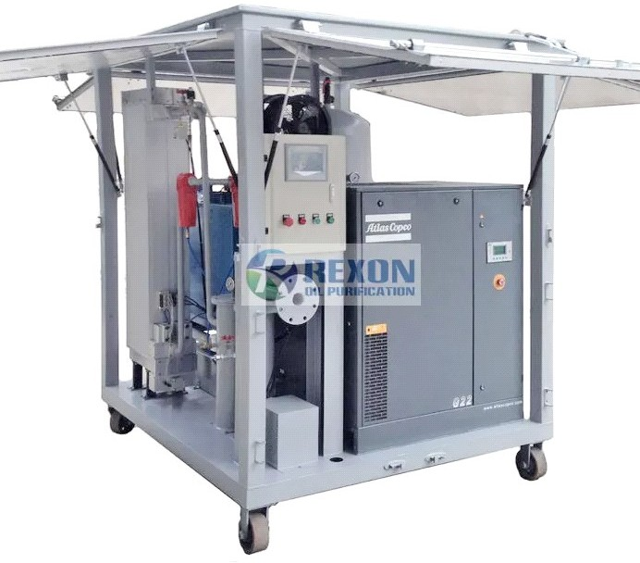
10 | High Voltage(Hi-Pot)Tester Capacity:125kVAC and DC | ModelNo.:HECL-125A  Huazheng Engineering Co. Ltd. | 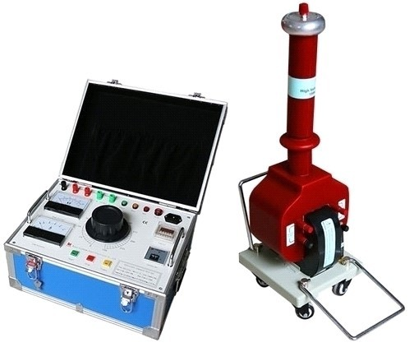
11 | Circuit Breaker Analyzer for testing closing time and opening time | ModelNo.:HYGK-306A  Wuhan HuayingElectric Company Ltd. | 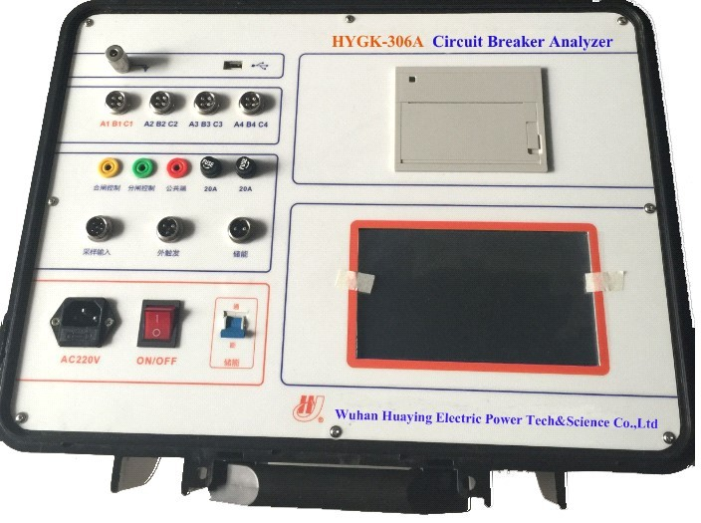
12 | Contact Resistance Measuring (CRM) kit for Circuit Breaker | ModelNo.:HYHL200A  Wuhan Huaying Electric Company Ltd. | 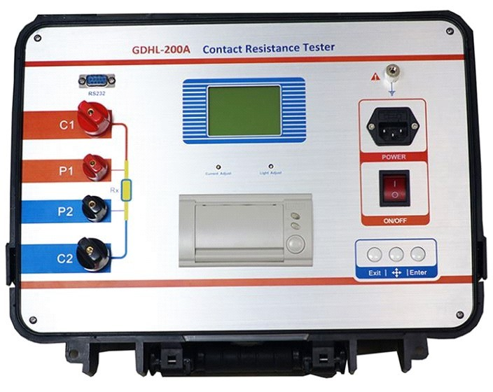
13 | 1000A primary current injection test set (Primary Current injection test Kit) | Model No.: HZ109S Huazheng Engineering Co. Ltd. | 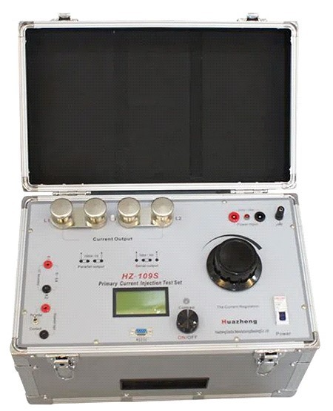
14 | Digital Multi-Meter and Clamp Meter | Brand: Uni-t/Victor,China | 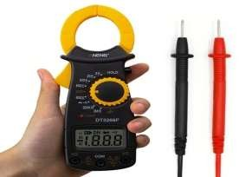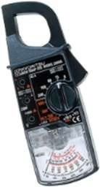

15 | Digital Multi Meter& Earth Resistance Measuring Kit | Kyoritsu,Japan | 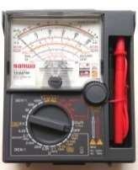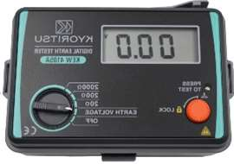
16 | McLeod Gauge for Measuring Vacuum Condition of Transformer | Brand:Oblum,India | 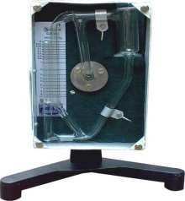
17 | Variable Transformer (Variac Transformer)Adjustable Manual Voltage Regulator 1KVA 5 Amp Output 0-220V | Brand :Shanghai Xiujiang ElectricCo.Ltd. | 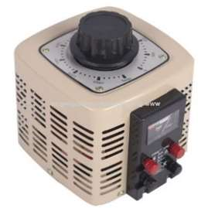
18 | 3000VAVoltageStabilizerfor Testing Equipment | Brand:Walton, Bangladesh | 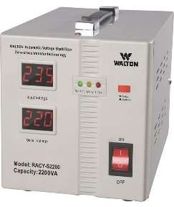
19 | 5kVand10kVDCInsulation Resistance Tester | Model No.:KY 3127 Brand:Kyoritsu,Japan | 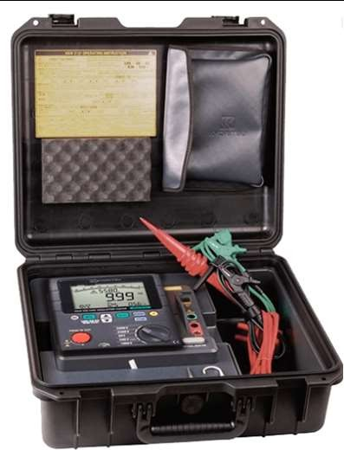
20 | PV Analysis Kit for Photovoltaic field testing and fault finding | Model :Z200 PV Brand:Volta Electric, China | 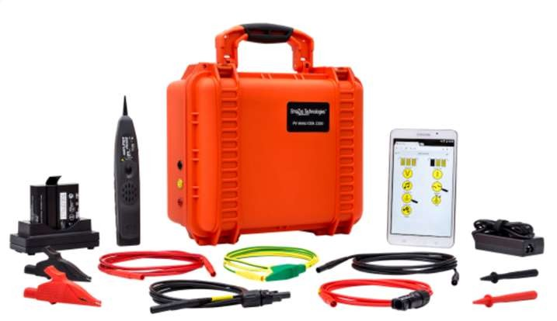
21 | Electrical Power Analyzer to achieve an accuracy of±0.03%at 50/60 Hz System | Model : WT5000 Brand:Yokogawa | 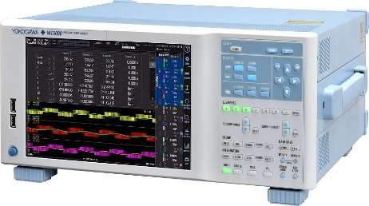

Others Testing Equipment:
22 | KYORITSU IR Tester | KEW 3127 | Kyoritsu-Japan | Insulation Resistance up to 1TΩ  Short-Circuit Current up to 1.5mA  Wide Test Voltage from 250V to 5000V  Diagnosis Function of PI and DAR  IEC 61010-1, 61010-2-030 CAT Ⅳ 300V /  CAT Ⅲ 600V Pollution degree 2,  IEC 61010-031, IEC 61326-1, 2-2
23 | Fluke IR Tester | 1555 FC | Fluke-USA | Insulation Resistance up to 1TΩ  Short-Circuit Current up to 1.5mA  Wide Test Voltage from 250V to 10000V  Diagnosis Function of PI and DAR  It can measure - Leakage current,  Capacitance along with IR.  IEC 61010-1: Overvoltage category II,  Pollution Degree 2.  IEC 61010-2-030: Measurement 600V CAT  IV / 1000V CAT III  IEC 61557-1, IEC 61557-2
24 | Ferrule Printing Machine | PT-E850TKW | Brother-India | Compatible Tube Diameter: 2.5 - 6.5mm  Supported Tube Type: PVC  Max Print Height for Tube: 6mm  Tube Print Speed: 40mm/sec  Multi Line Printing for Tube: Up to 2 lines  Maximum Tape Width : Up to 36mm  Label Print Resolution : 360dpi  Label Print Speed : 60mm/sec  Multi Line Printing for Label – : Up to 17 lines
25 | True-RMS AC/DC Clamp Meter | CM4373 | Hioki-USA | Measures AC, DC, and AC+DC current up to 2000A  True-RMS measurements deliver accurate results, even for distorted wave forms.  Offers high-voltage measurement of up to 1700V DC under certain conditions*  Dust proof and waterproof performance with IP54 rating.  Suitable for tough environments with expanded -13 to 149°F (-25 to 65°C) operating temperature range.
26 | CT Analyzer | TE656S | Omicron, Austria
27 | SFRA Testing Set | FRAX 99 201442 | Megger -Sweden
28 | Contact Resistance Tester/ Low Resistance Ohm Meter | DLRO- 102114325 | Megger,UK
29 | IR Test Kit-10kV | 10kV S1-1068-162099600 | Megger,UK
30 | Circuit Breaker Analyzer | TM17602100766 | Megger, Sweden



